Screen 1

Show expanded by default

Note – only a weight should be in the header 176.5

Change header to match Stella Smith previous header

Change facility / user name

Should be scrollable to the bottom of page (this is just a snip)

When clicked – the navigation will be outlined.

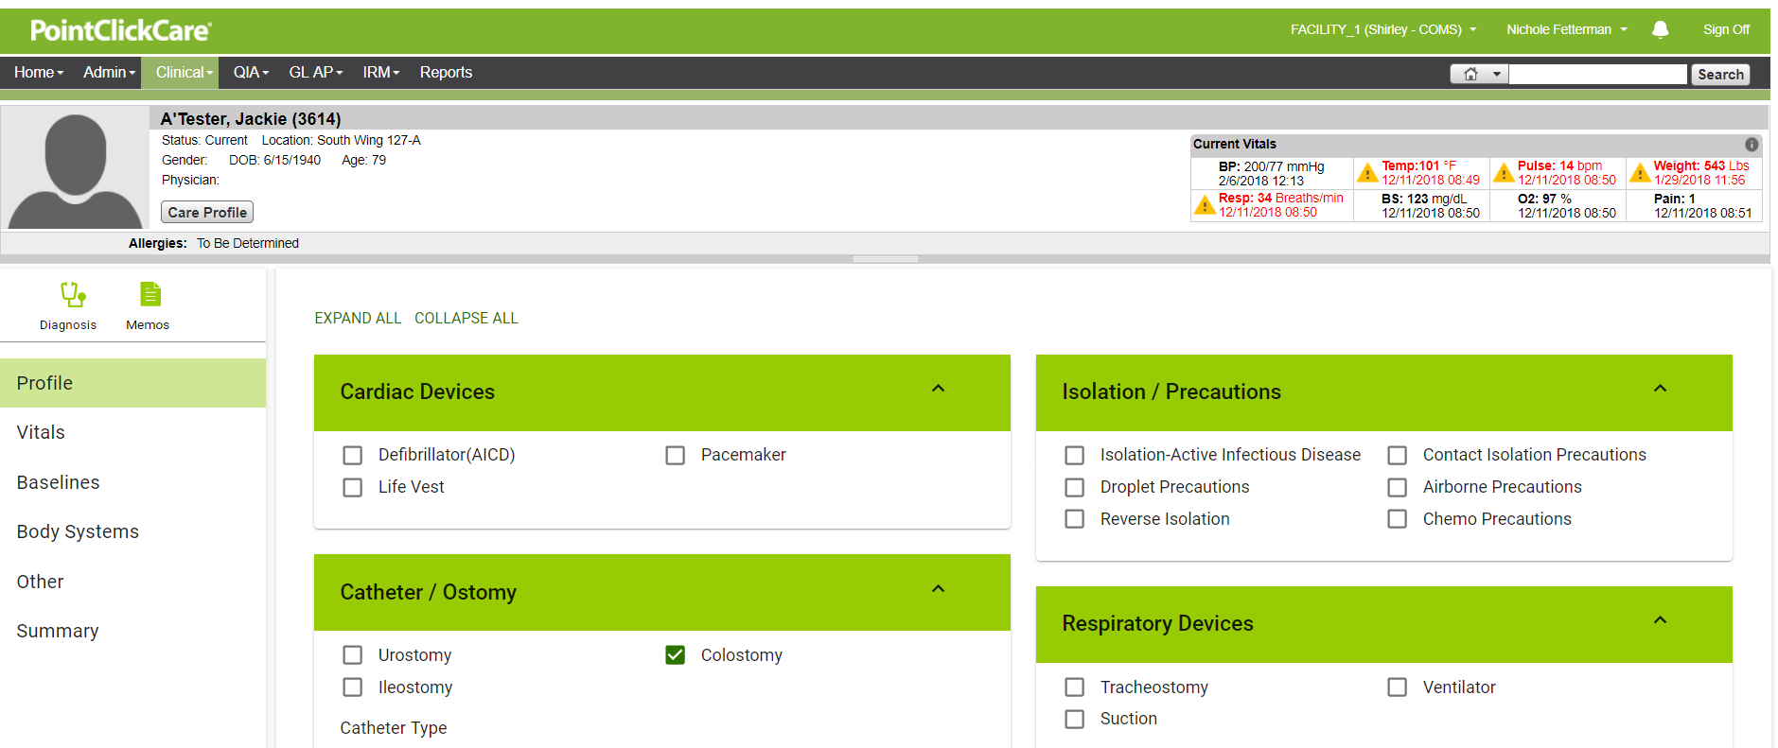

Screen 2 Vitals

All header updates, as mentioned above

Upon landing – show vitals below completed.

When clicked – upper right corner outlined in red. Then – when clicked clinical suggestions has those shown selected and it outlines in red box.

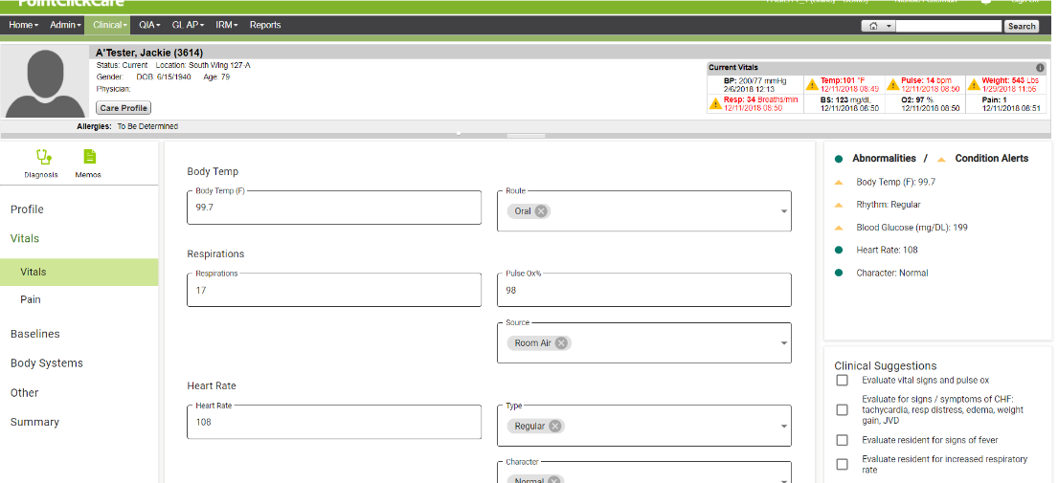

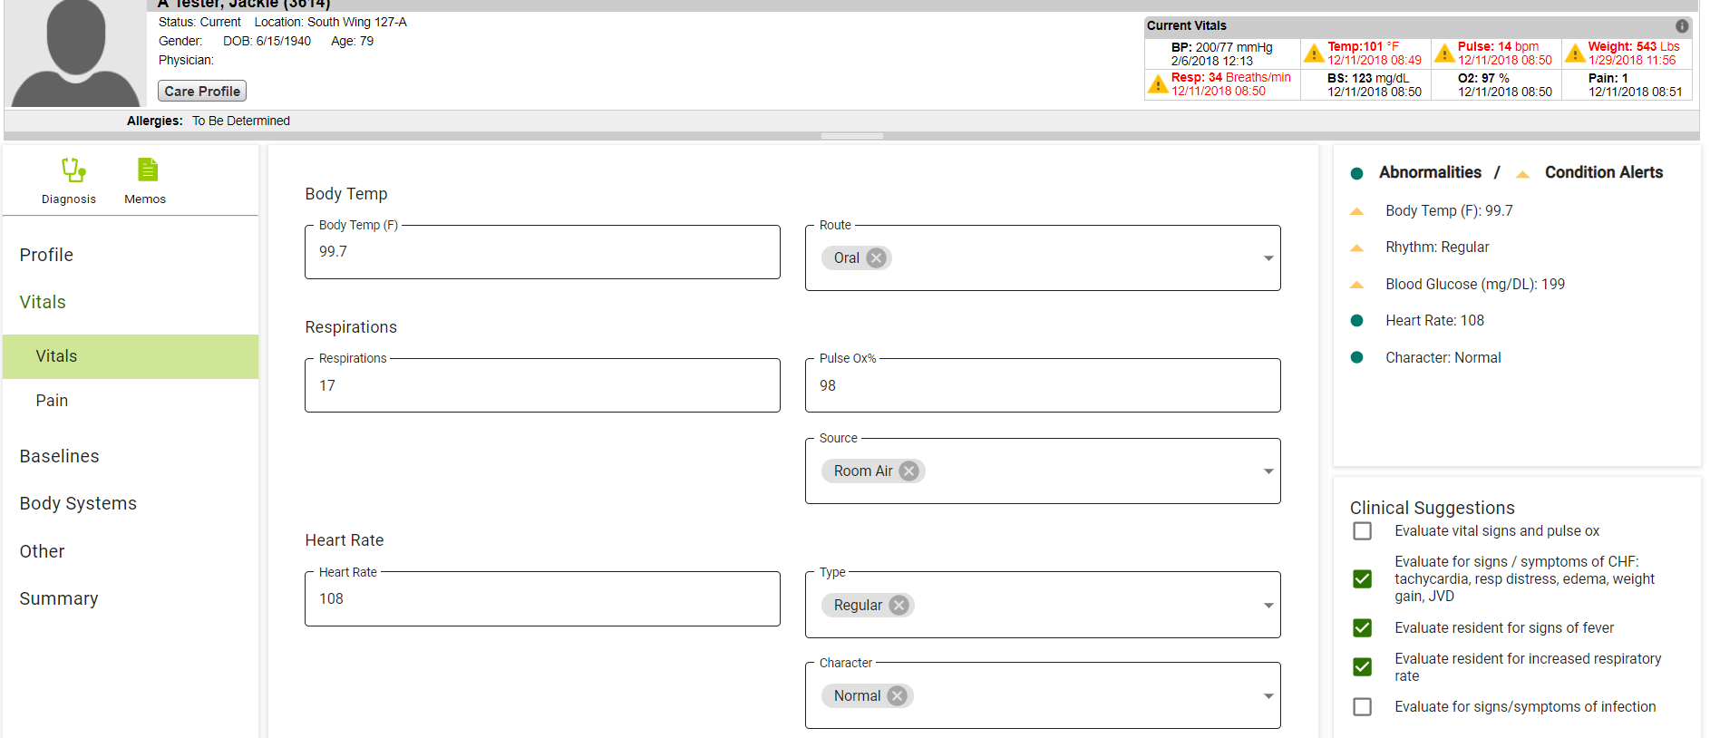

Screen 3

Default is empty

Header updates mentioned on screen 1 apply to here too

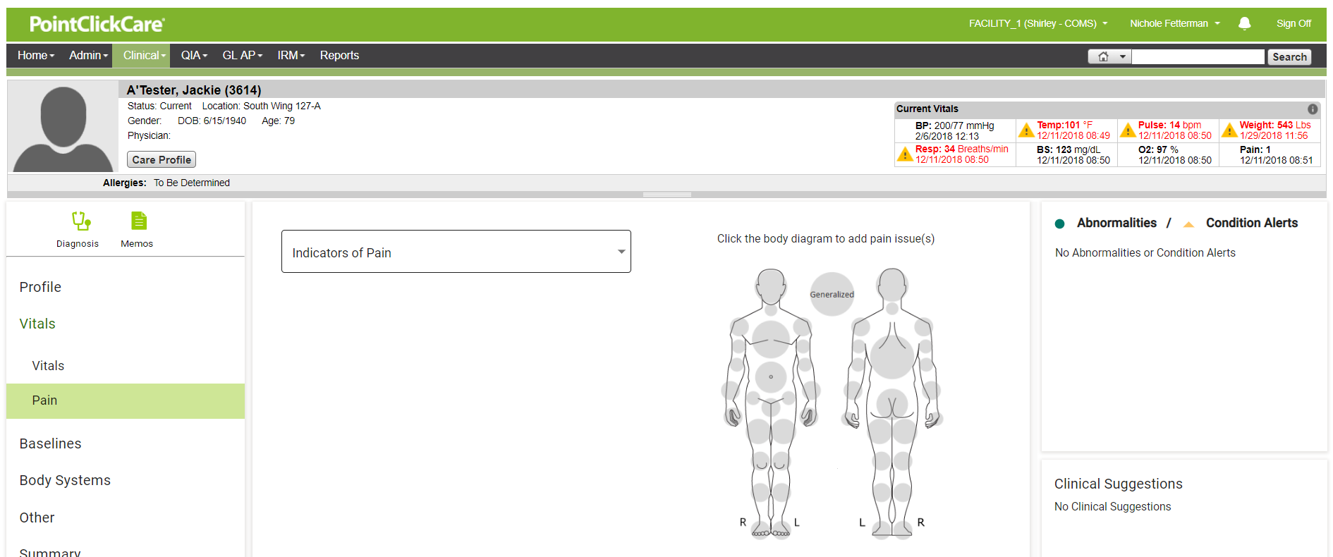

Screen 4

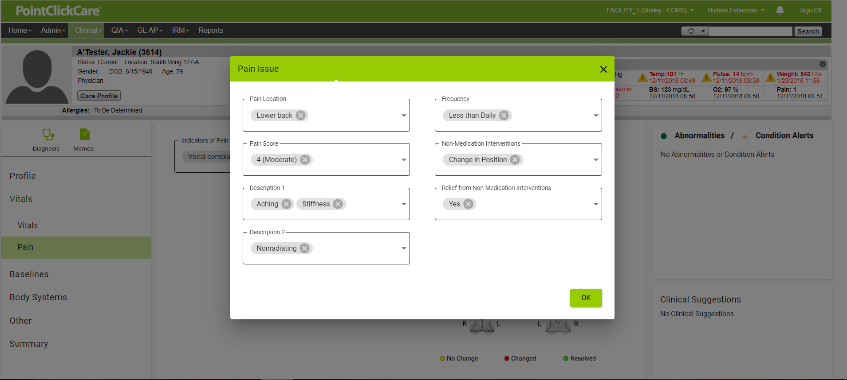

Screen 5

Include header

We will have to add clinical suggestions

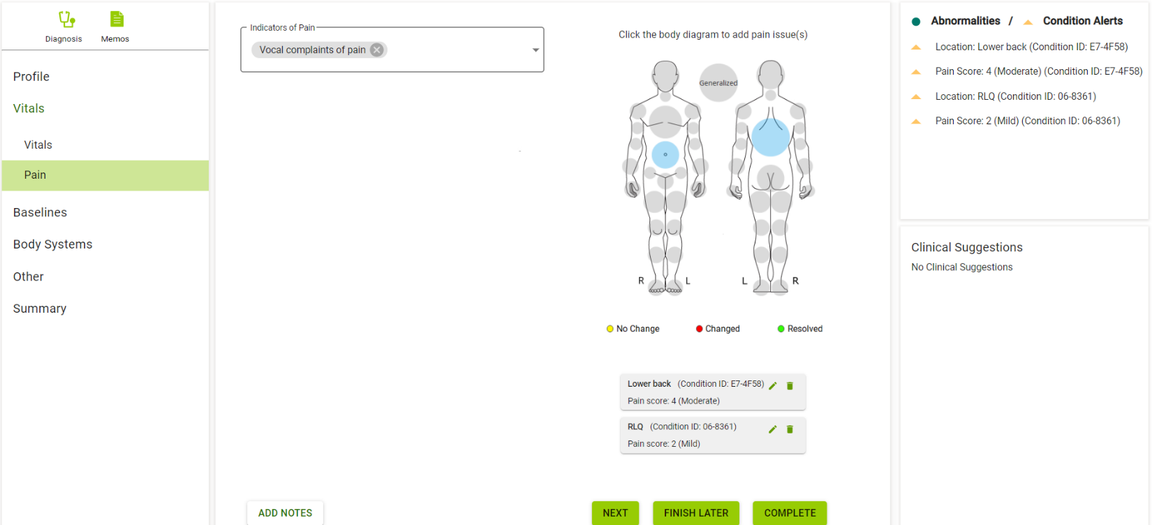

Screen 6

Header – carry it over

Outline the respiratory baseline when clicked

Preselect Neurologic – met

MS – not met

Mood & behavior – not met

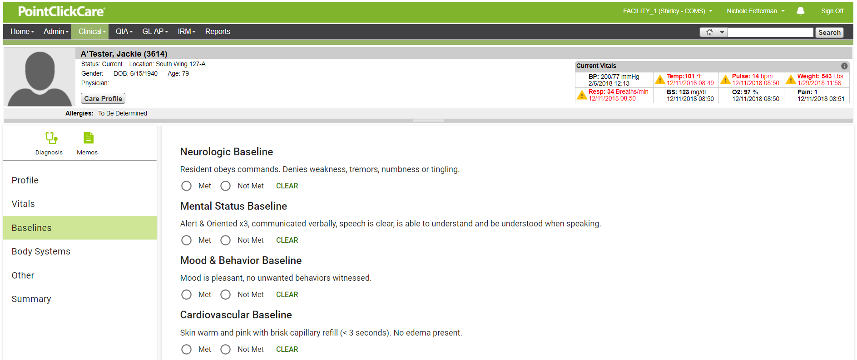

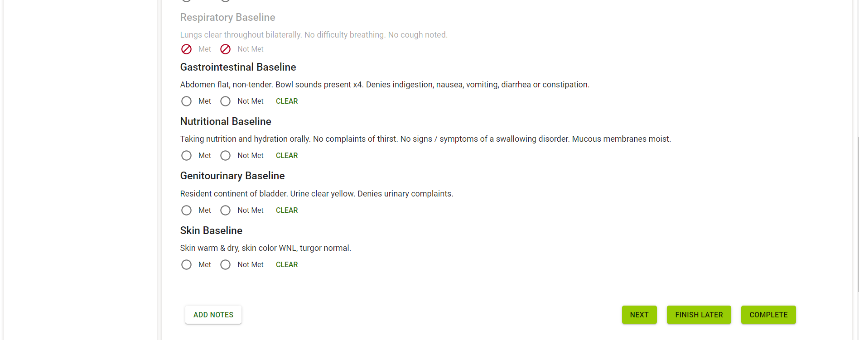

Screen 7

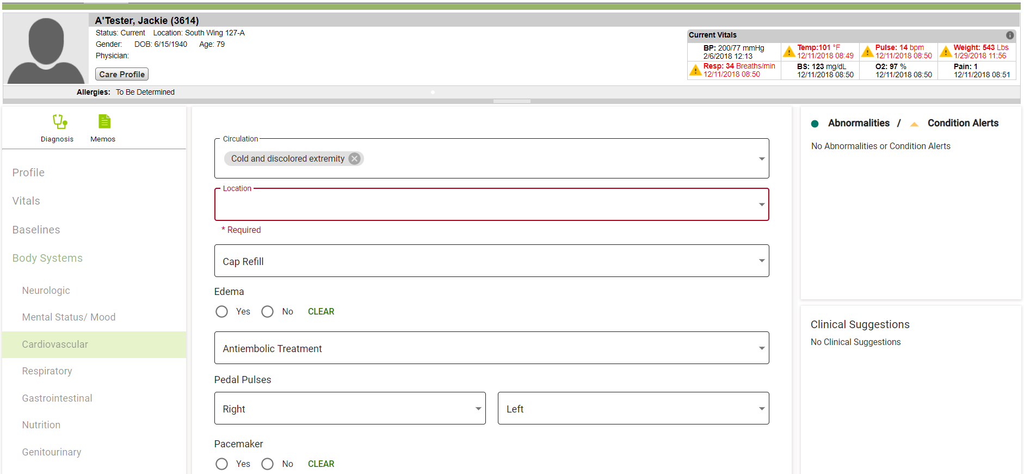

Screen 8

Screen 9

